

DRAFT
EXECUTIVE COMMITTEE MEETING
AGENDA – AUTUMN 2026

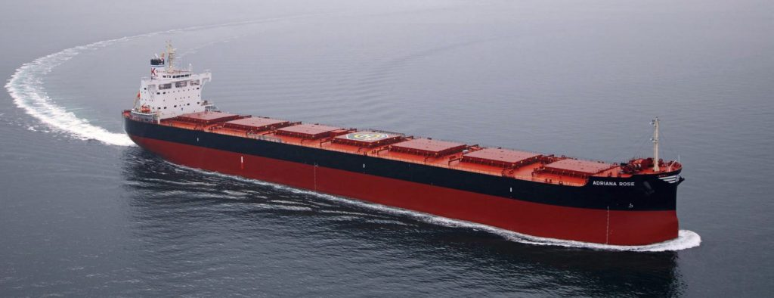

to be held in person with optional remote participation at the
The Westin Singapore
Ballroom
(12 Marina View, Asia Tower 2, Singapore 018961)
Tuesday 15 May 2026 from 09:00 to 16:30 local time

EXECUTIVE COMMITTEE MEETING TIMETABLE
DATE | TIME | LOCATION
15 May 2026 | 09:00 to 16:30 | The Westin Singapore, 12 Marina View, Singapore

Session 1 – Full Members Only
TIME
08:30 to 09:00 | Registrations
09:00 to 09:10 | Start / Introduction / Approval of minutes
09:10 to 10:00 | Membership, Administration
10:00 to 10:10 | Report / Endorsement of Technical Committee meeting
10:10 to 10:45 | Dry Bulk Shipping and INTERCARGO initiatives
Key themes around
- STS Guidelines/stakeholders engagement
- Australia ports and other stakeholders engagement
- Advisory Associate members Panel
- Quality Panel, RightShip and charterers
- Roundtable of international shipping associations
- IMO Decarbonisation pathway
- EU / regional issues
- other fora / initiatives (eg Together in Safety, Tripartite, Green Award)
10:45 to 11:15 | Coffee Break

Session 2 – Open Session – Full & Associate Members and Invited Guests
TIME
11:15 to 12:00 | Dry Bulk Shipping and INTERCARGO initiatives
- Presentation: “DryBMS Structure and Future Vision” by DBCE
- Presentation: “Update on Geopolitical developments / MEG” by Institute of Chartered Shipbrokers
12:00 to 12:40 | GHG emissions  IMO / EU / regional developments
- Presentation: “Alternative Fuels: The Big Picture” by Bureau Veritas
- Presentation: “Wind Assisted Propulsion System – An Operator Perspective” by Berge Bulk
12:40 to 13:00 | INTERCARGO Digitalisation Projects
13:00 to 14:00 | Lunch

Session 3 – Open Session – Full & Associate Members and Invited Guests
TIME
14:00 to 14:45 | Dry Bulk Carrier Operational Topics
INTERCARGO Casualty Report / Liquefaction and other root causes
Port State Control of Bulk carriers
- Presentation: “Operational Optimisation” by Fleet Management
- Presentation: “Smarter Fleets, Safer Cargo: Real-Time Intelligence for Dry Bulk Operators” by ShipIn

14:45 to 15:15 | Coffee Break

Session 4 – Open Session – Full & Associate Members and Invited Guests
TIME
15:15 to 15:30 | Human Element Topics
INTERCARGO Benchmarking Report
Seafarers’ welfare / wellbeing
Suggested updates by members for INTERCARGO Benchmarking project

15:30 to 15:50 | - Presentation / briefing by ASPIDES
15:50 to 16:30 | AOB/Conclusion of ExCom Meeting

Anti-trust and Competition Law Compliance Statement

This meeting is to be conducted under the INTERCARGO Anti-Trust Policy

INTERCARGO is firmly committed to maintaining a fair and competitive environment in the world shipping trades, and to adhering to all applicable laws which regulate shipowners and their representative bodies in these markets. These laws include the antitrust laws, which the United States of America, the European Union and many nations of the world have adopted to preserve the free enterprise system, promote competition and protect the public from monopolistic and other restrictive trade practices. All meetings INTERCARGO will be conducted in compliance with such laws and regulations.

As part of those Guidelines, neither INTERCARGO nor its members shall engage in any discussion on or agree upon: fixing of terms, prices, rates; matters relating to particular customers or suppliers; boycott or blacklist particular customers or suppliers; divide markets or customers; otherwise seek to distort competition. All advice to members on, inter alia, chartering terms including information on model clauses shall be non-binding and for information only.

NOTES
Note 1: All sessions are open to Full Members of INTERCARGO who have timely registered – please refer here.
Note 2: Comments via emailing from Full Members who are unable to attend the meeting, but willing to participate in the formulation of INTERCARGO’s strategy, are very welcome.

Agenda
1. Welcome/Introduction (09:00-09:10)

Introduction - Minutes of previous meeting (04 November 2026) –
Matters Arising not otherwise on this agenda

The Chairman will welcome the attendees to the meeting.

The Committee will be invited to approve the Minutes of the previous meeting (available for reference at https://www.intercargo.org/excom-may-2026/).

2. Membership, Administration (09:10-10:00)

The Executive Committee will review, and be invited to decide where applicable, on:
- An up-to-date Administration report will be reviewed, including:
- Membership update, Bank accounts, Financial statements / Income & Expenditure.
- Communication / Circulars / Publications
- Membership and AGM related issues
- Date and Place of next Executive Committee meeting

3. Report / endorsement of Technical Committee meeting (10:00-10:10)
The discussions held at the Technical Committee meeting the preceding day and relevant recommendations will be presented for approval, where relevant, by the Executive Committee.

4. Dry Bulk Shipping and INTERCARGO initiatives

4.1 Full Members Session (10:10-10:45)

The Committee will be presented and discuss the latest developments on the following topics:
STS Guidelines/stakeholders engagement

Australia ports and other stakeholders engagement

Advisory Associate members Panel

Quality Panel, RightShip and Charterers

Roundtable of international shipping associations

IMO Decarbonisation pathway

EU / regional issues

Other fora / initiatives (e.g. Together in Safety, Tripartite, Green Award)

4.2 Associate Members Session (11:15-12:00)
Summary of above topics
DBCE & DryBMS
- Presentation: “DryBMS Structure and Future Vision”
Speaker: Michael Phoon, DBCE

Dry Bulk Shipping, Piracy & Security
- Presentation: "Looking Ahead: Geopolitical Tectonic Plates Shifting"
- Speaker: Punit Oza, Institute of Chartered Shipbrokers

5. GHG Emissions (12:00-12:40)
The Committee will be presented and discuss the latest developments on the following topics:

IMO
EU / Regional GHG Developments

- Presentation: “Alternative Fuels: The Big Picture”
Speaker: Gerrit Bunt, Bureau Veritas

- Presentation: “Wind Assisted Propulsion System – An Operator Perspective”
Speaker: Sylvain Julien, Berge Bulk

6. INTERCARGO Digitalisation Projects (12:40-13:00)
The Committee will be presented and discuss the latest developments on the following topics:

INTERCARGO website update

7. Dry Bulk Carrier Operational topics (14:00-14:45)

The Committee will be updated, and invited to decide where applicable, on the below key topics:

INTERCARGO Casualty Report / Liquefaction and other root causes

PSC / MoUs

Terminal reporting

Attracting and retaining seafarers in the dry bulk sector: Criminalisation & fair treatment

- Presentation: “Operational Optimisation”
Speaker: Pankaj Singhal, Fleet Management

- Presentation: “Smarter Fleets, Safer Cargo: Real-Time Intelligence for Dry Bulk Operators”
Speaker: James Solada, ShipIn

8. Human Element topics (15:15-15:30)

The Committee will be updated, and invited to decide where applicable, on the below key topics:

Crew Welfare and Wellbeing initiatives

Benchmarking Report 2025

Suggestions from members for changes to INTERCARGO Benchmarking Project

9. Security Briefing Update by ASPIDES (15:30-15:50)

- Presentation: “Security Briefing Updated”
Speaker: ASPIDES

10. Any Other Business (15:50-16:30)

The Committee will be invited to raise any other business

--
Date and Place of next Executive Committee meeting

- CONCLUSION OF EXCOM MEETING by 16:30 –

APPENDIX 1

Meeting Venue Address & Map
Ballroom 1
12 Marina View, Asia Square Tower 2, Singapore 018961

+30 21 0890 1000

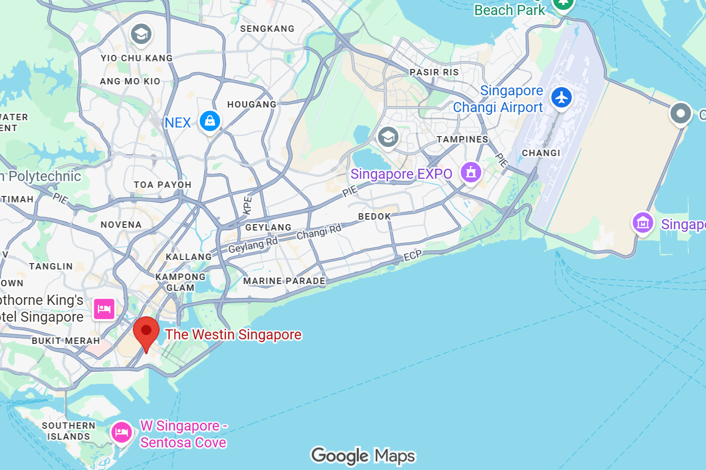

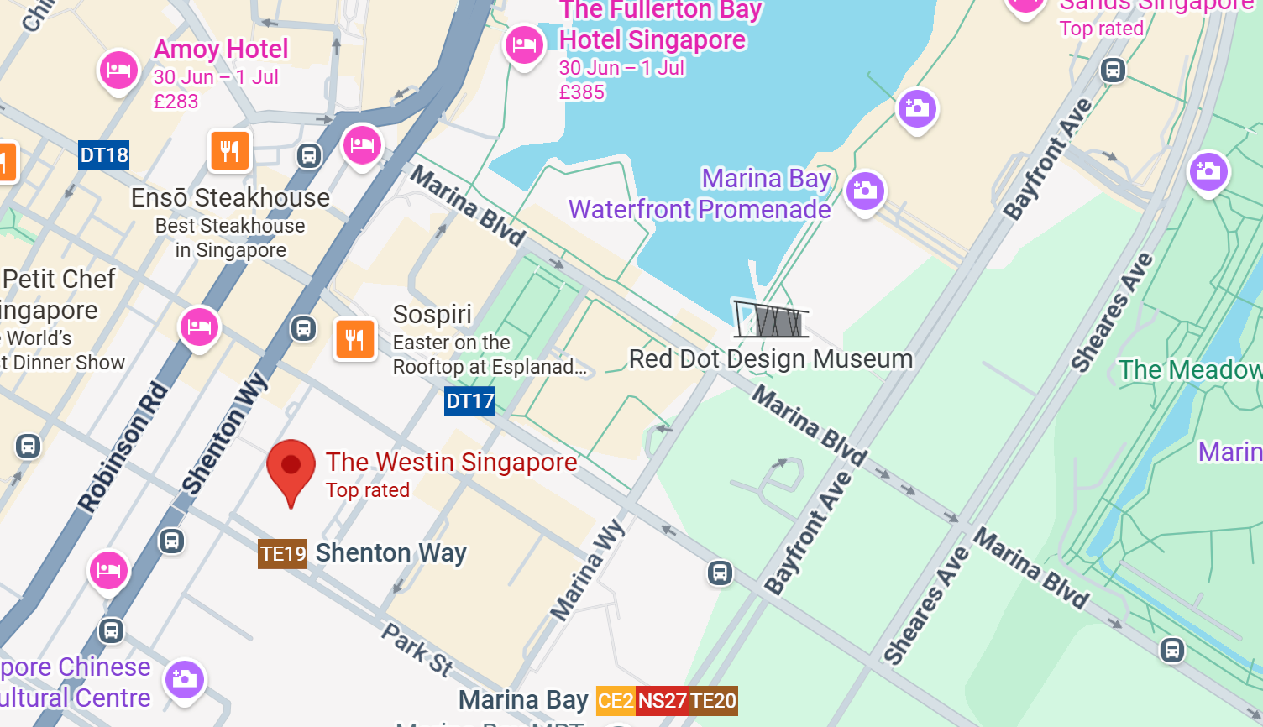

Full address & map in Appendix 1 ² Timetable subject to change

